CSULB — College of Engineering
Computer Engineering
Senior Design Project
CECS 490A
Author: Rodrigo Becerril Ferreyra
Teammates: Colton Curtis, Kevin Nguyen, Ethan Hua
Professor Dan Cregg
Table of Contents
Executive Summary 3
Responsibilities 4
Overall Progress Report 4
Concerns 5
Expected Final Grade 6

Executive Summary
Our project, which is called the Aftermarket Car Security System (but whose name is subject to change) is an embedded system which has the ability to connect to the Internet and interact with the user. It uses a wide variety of sensors in order to correctly determine whether or not the user’s car has been damaged (e.g. door-dinged) or if any component of the car is being vandalized or stolen (for example, a tire). It communicates with the user’s smartphone using technologies such as SMS and the Cloud (Amazon Web Services). The ACSS sends live footage from its cameras to the user’s phone via a website. The user can then watch the live footage and decide whether or not the event was a false alarm; the ACSS can then be turned off remotely if necessary.
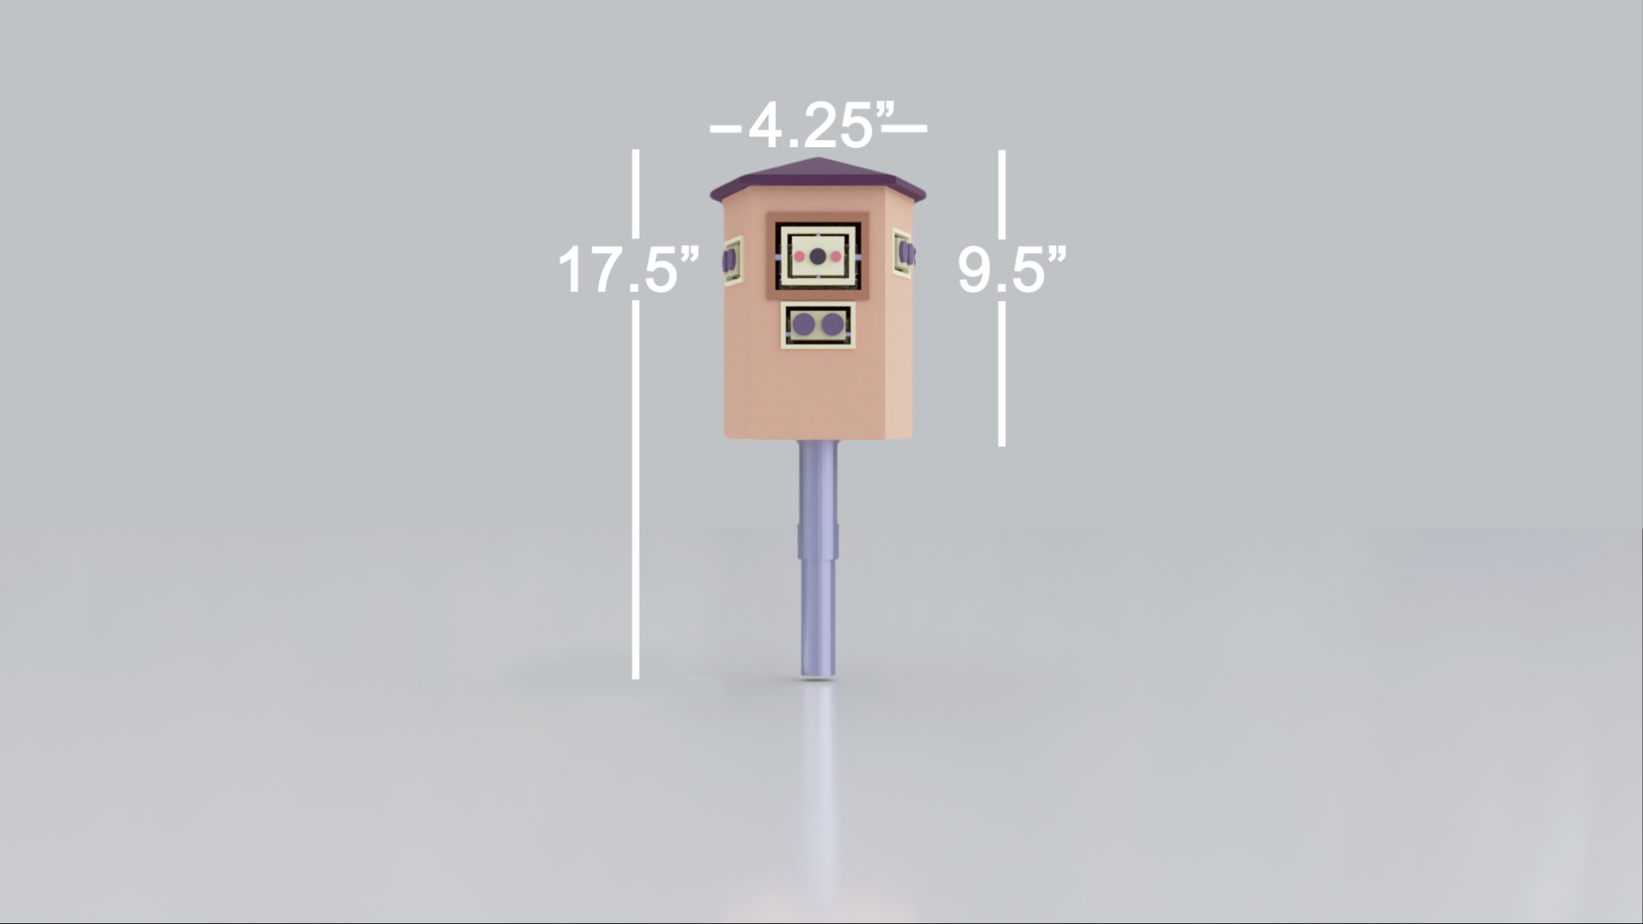Figure 1: A render of a 3D model of the ACSS. Model by Colton Curtis.

Responsibilities
Up to this point, I have had several different responsibilities. At first, I was in charge of creating a mock-up of either an Android mobile application or a web application (webapp) and to provide a comparison between the two. This task was due on 16 September 2021. As a team, we decided to go with a webapp so that we could target all mobile operating systems instead of just Android. After that, my task became to compare our security system and other systems already on the market. This task was due on 23 September 2021. For next week, my task is to code the program that puts the two camera inputs together into one video file that is easy to livestream to the website. This task is due on 07 October 2021.
In the future (two weeks and beyond) my job is to investigate, create, and implement several different (software) algorithms that will work closely with our system in order to perform vital tasks, such as deciding when to turn the camera on, detecting whether or not the camera is detecting a human (computer vision), and deciding whether or not to sound the alarm and alert the user (to avoid too many false positives).

Overall Progress Report
I believe that our project is progressing very smoothly. We are on schedule with all our tasks, and are constantly thinking of ways to add to our system or removing planned features that may not perform the functions that we originally planned. An example of this is the fact that we originally planned to include a microphone in the design to detect if there was a loud noise (which could be indicative of a saw which can be used to steal a catalytic converter, or may be indicative of the car’s built-in alarm sounding if the car is broken into), but we decided to scrap this idea due to the fact that there are many loud noises on city streets, and it would not be worth the trouble to implement machine learning algorithms to filter out sounds we are not interested in. Currently, we are debating whether or not we should scrap the Bluetooth tags used to detect which car part is being stolen.
As for the future, we have many things planned out in Tasks and each team member has a clear goal for next week and the weeks to come.
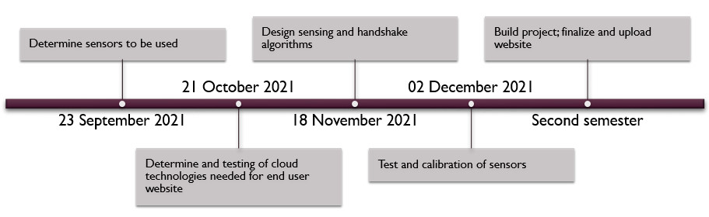Figure 2: A generalized timeline of out team's plans for the rest of the semester.

Concerns
My greatest concern for this project is cost. Many of the components and sensors used for this project are relatively costly (for example, one Bluetooth development kit is $25) and the costs can add up quickly. In addition, we are paying everything out of pocket, and it is worse in this AMI environment where it is very easy for costs to accumulate on one person. We are already mitigating this issue by replacing our original sensor ideas with sensors that are less costly, but we might have to implement more cost-cutting measures.

Expected Final Grade
I expect to receive an A for this class. The purpose of this class, according to the CSULB catalog, is to “work in teams to define a problem, complete a design and provide both a written report and a multimedia presentation at the end of the semester.” So far, we are working in teams and have defined a problem, and are delivering both written and multimedia reports; simply by completing the requirements for this class, our team should receive a B.
The grade of an A implies going beyond the class requirements and completing all the work assigned. I believe we are going above and beyond this by gathering our knowledge of previous classes, and acquiring new knowledge not taught in our classes, and bringing them together in a product that could compete with other real security systems on the market today. For example, our team is implementing machine learning-based computer vision algorithms to detect the presence of humans. Machine learning, a subset of artificial intelligence, is either a scary or an almost science-fiction topic for most Computer Engineering students, and maybe only one or two groups are implementing a similar topic, but we are planning to implement it in our project. In addition, we are thinking about topics that pertain to real-world constraints, such as time-to-market, cost analysis, ease of use to the end-user, and comparison and rivalry of our competitors’ systems that pertain to marketing our product, and we are implementing these constraints into our design as we move forward. It is for these reasons that I believe my team and I should all receive an A this semester.

